**Lab 9: Integration of Static code analysis tool with Jenkins**

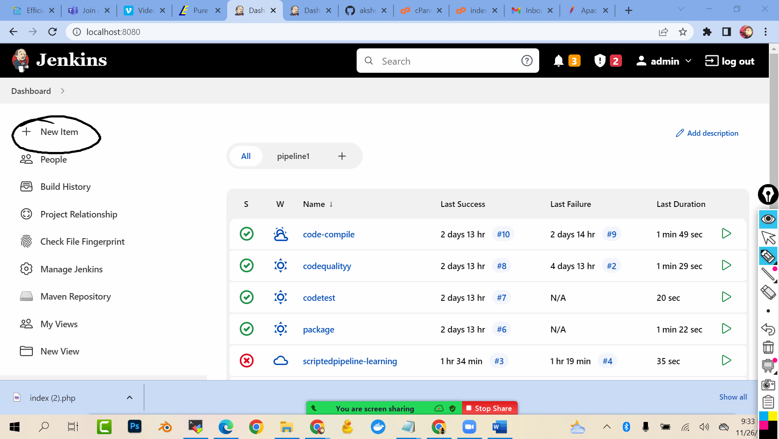



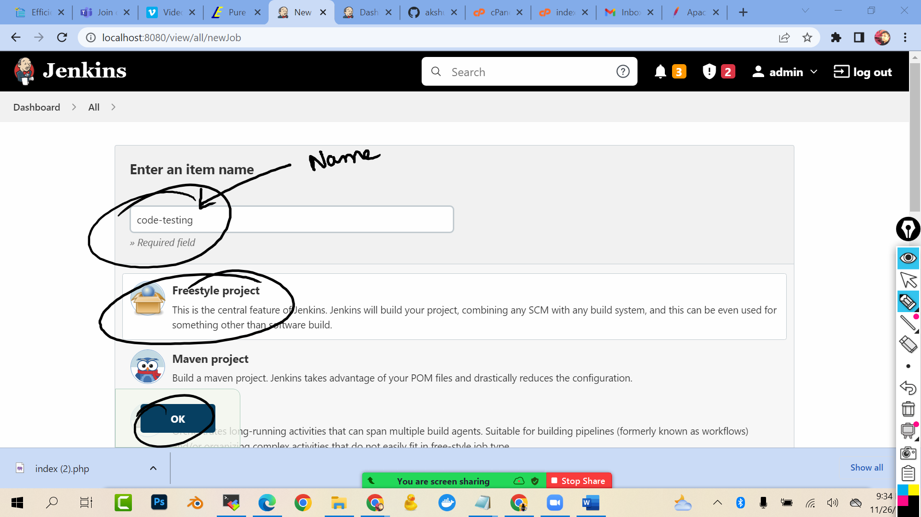

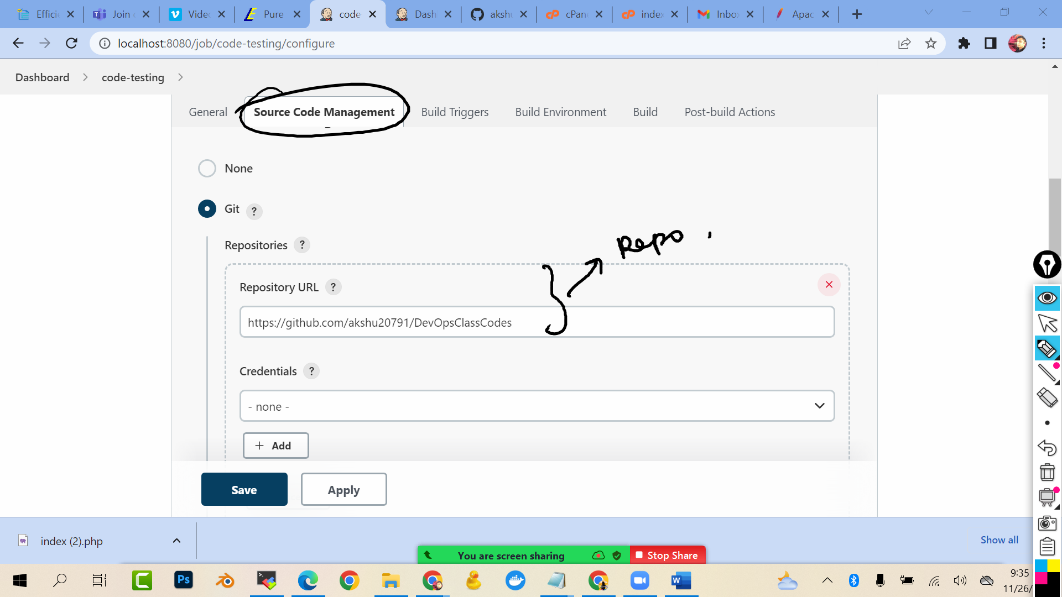

**Github:** [**https://github.com/akshu20791/DevOpsClassCodes**](https://github.com/akshu20791/DevOpsClassCodes)

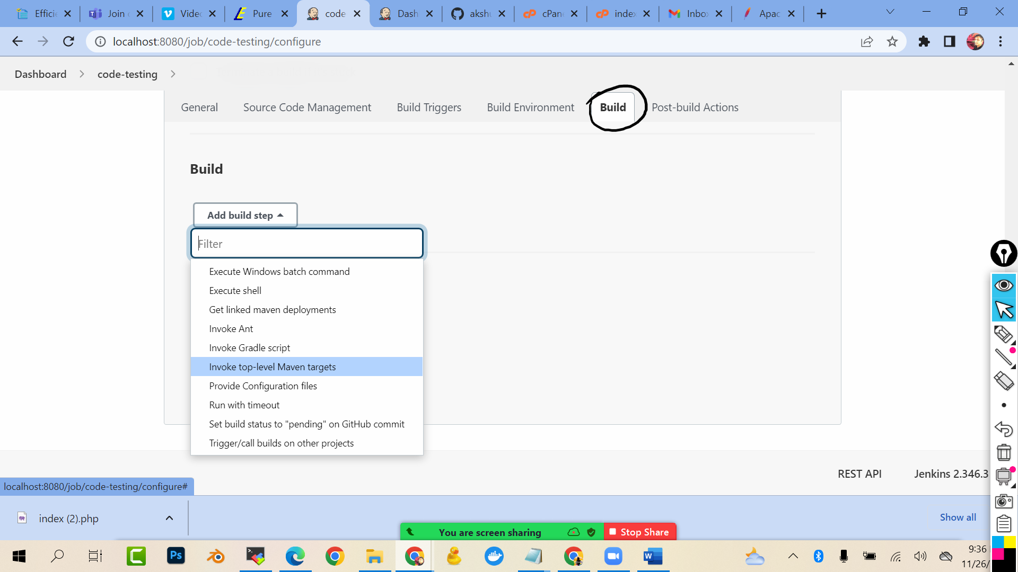

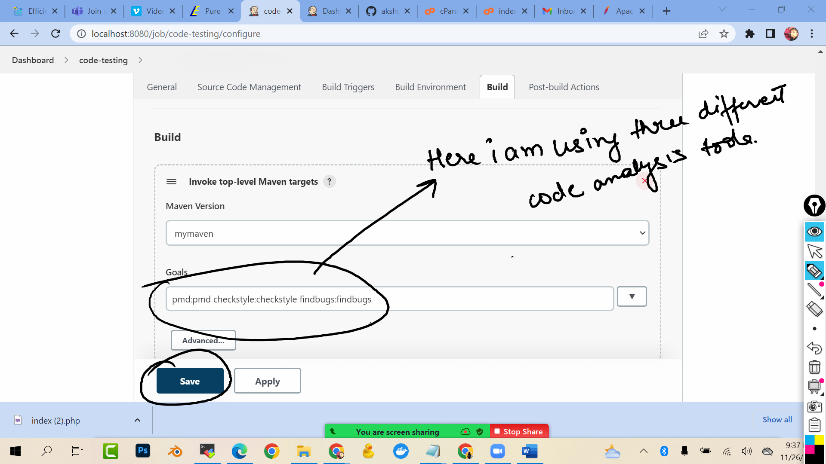

**But the problem how to view the report ??**

**For that go to manage Jenkins -> plugins -> download warning next generation plugin**

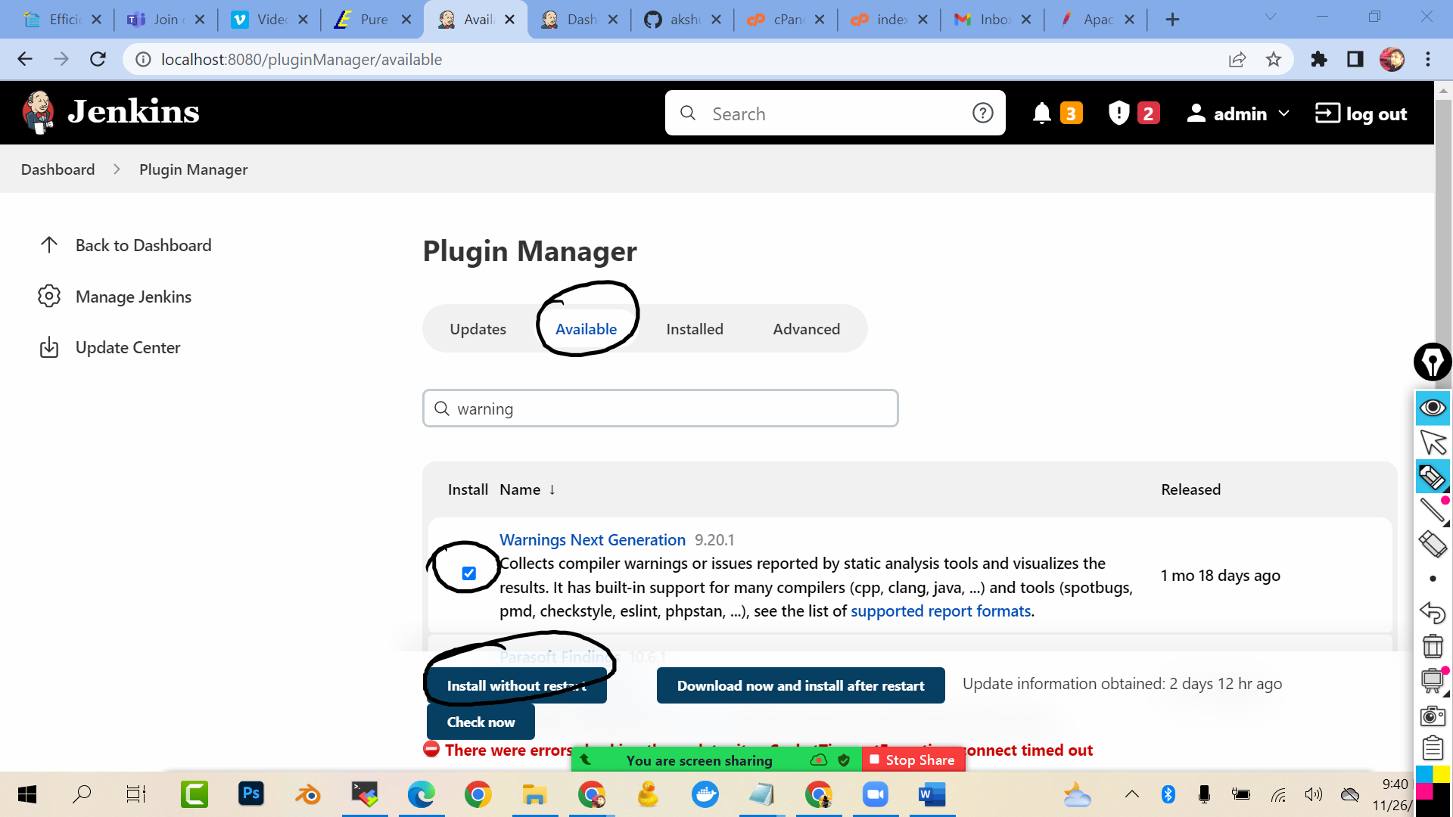

**Go to code-test- > configure -> post build steps**

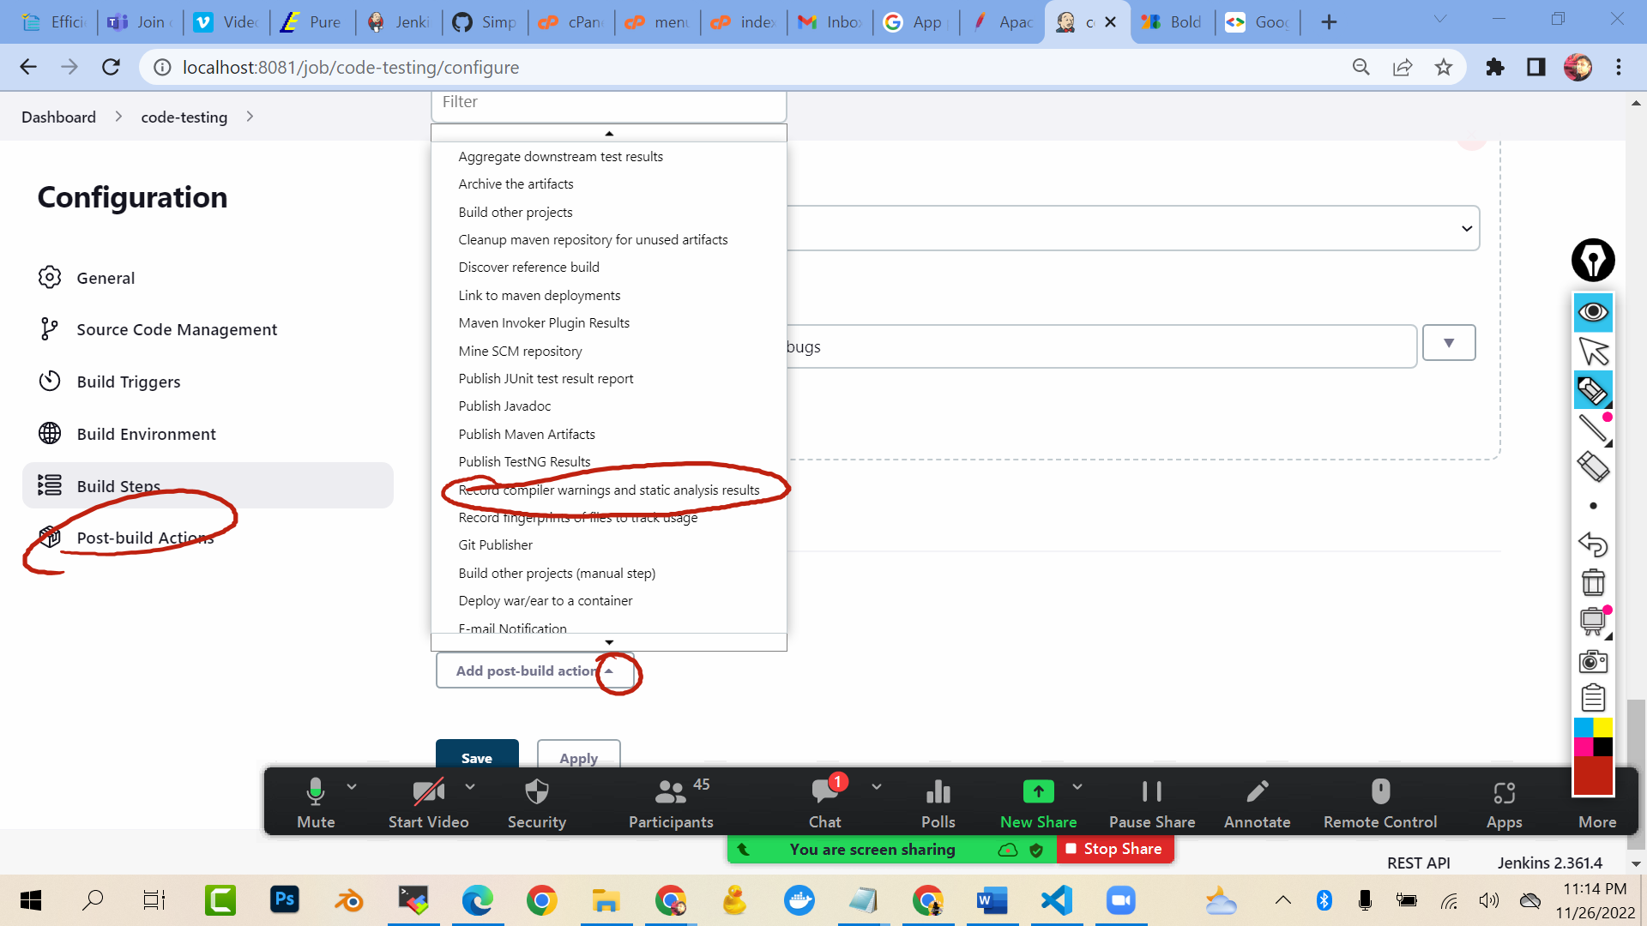

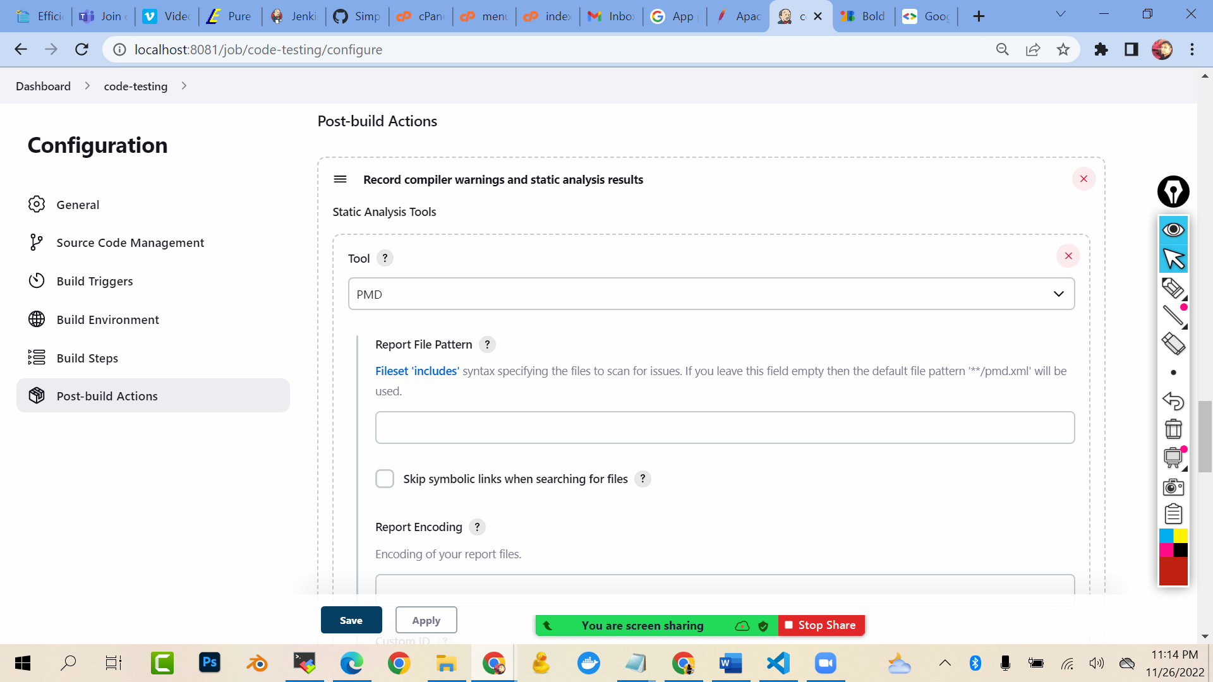

**Add tool**

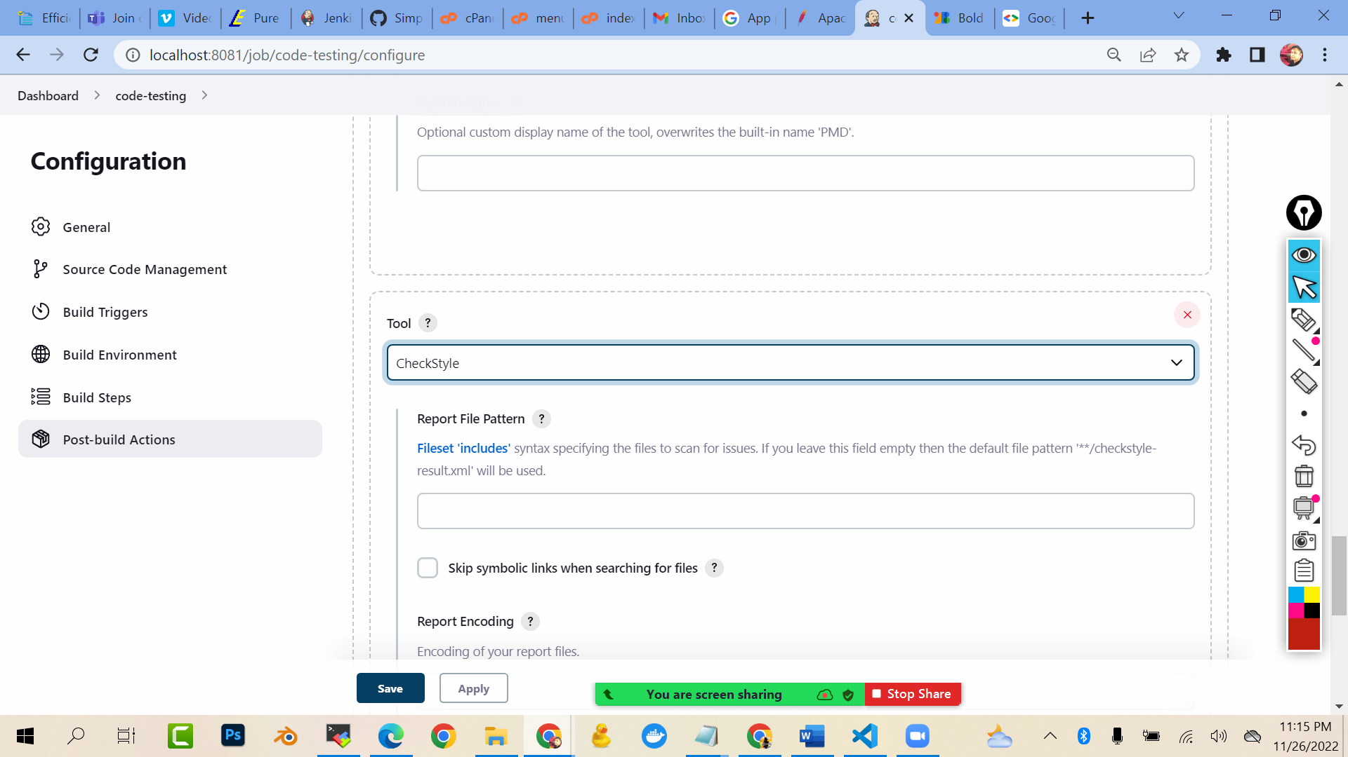

**Add tool**

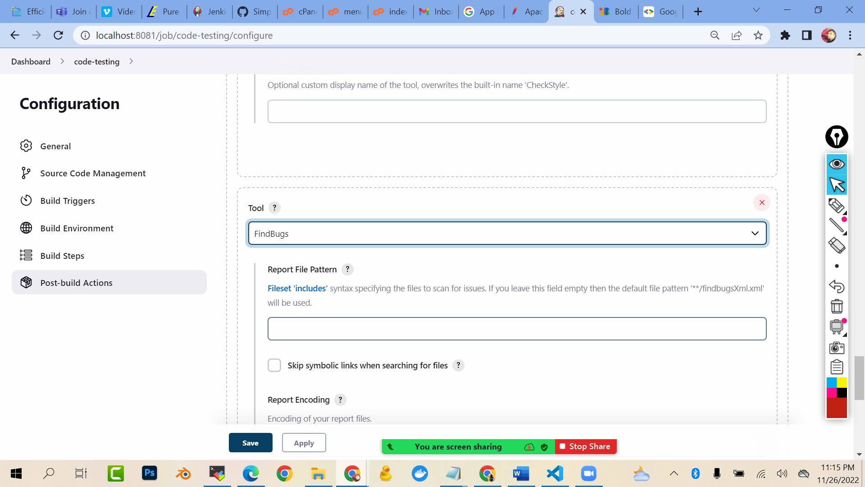

**Save and build now**

